Asimov, Young Ghosts, Harper & Row 1985 Stated First Edition, First Print full print line. As new dust jacket price $11.95. As new hardcover with all 210 pages tightly bound with no marks of any kind. 8vo cover art Fred Marcellino. ISBN 0060201711

ID 000347 Price $20 Box 7
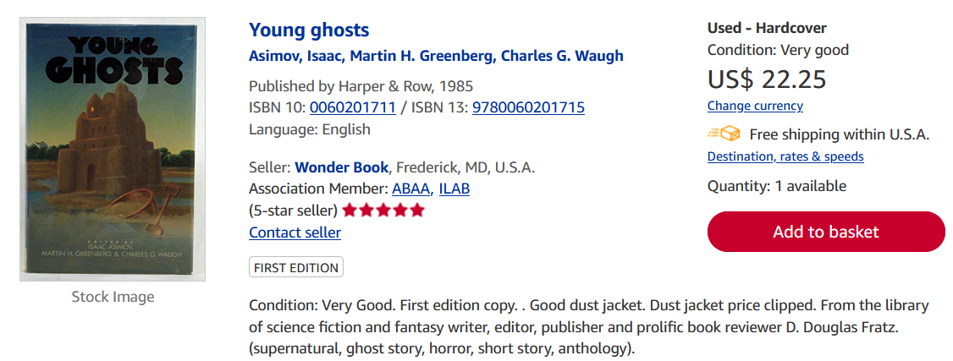
AbeBooks
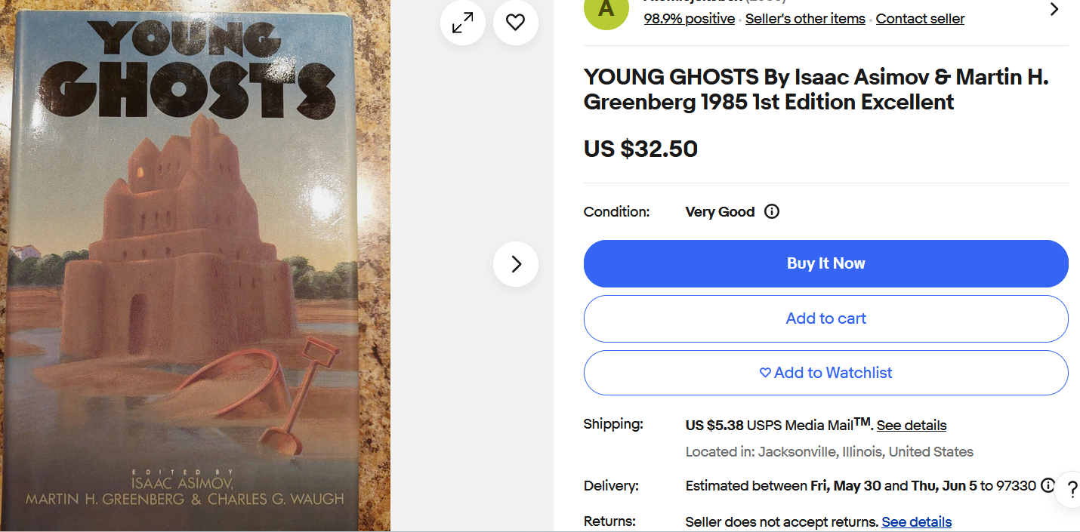
Ebay

